Waterfall
Name:

An Anti-Gravity Investigation

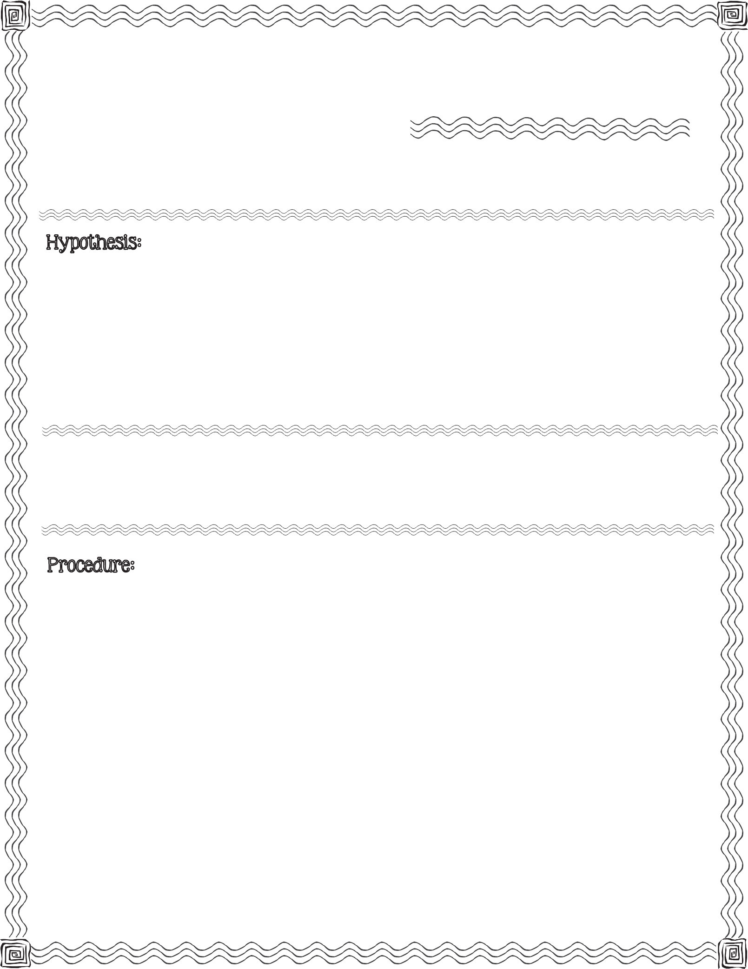

First, read the procedure below. Next, write your hypothesis for what you think will happen when turn over a handkerchief covered glass filled with water.

tall glass with a round edge, handkerchief, pitcher of water, large bowl

- Place large bowl on table. Conduct the following steps above bowl.

- Drape the handkerchief over the top of the glass. Push the center of the handkerchief down into the glass.

- Fill the glass 3/4 full with water by pouring into the middle of the handkerchief.

- Slowly pull the handkerchief down the sides of the glass making it tight across the top.
2013 Mrs. B’s Best

- Grip the ends of the handkerchief at the bottom of the glass.

- Place one hand over the mouth of the glass and turn it over with the other hand.

- Slowly pull your lower hand away from the glass.

- Observe. Record observation (on back).
c

Illustrate what you observed when you turned the glass filled with water over.

Describe what is happening in your illustration.

Did most of the water remain in the glass? Yes No

Conclusion & Results:

Compare your hypothesis to the real outcome:

WaterfallAn Anti-Gravity Investigation

