Water Wanderer
Name:

A Cohesion Investigation

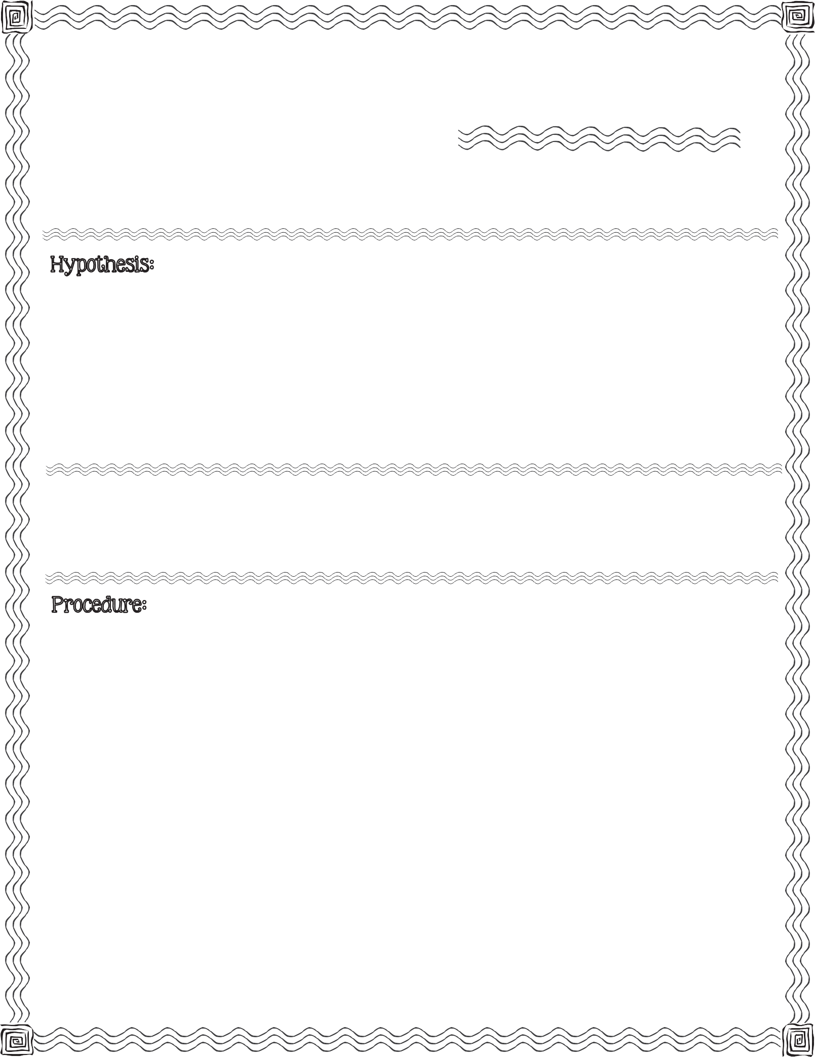

First, read the procedure below. Next, write your hypothesis for what you think will happen when you pour water from one cup to another cup attached only by a string.

2 plastic cups, white cloth string, water, scissors, tape, ruler, measuring cup, large pan or dish tub

- Place the large pan or dish tub on your workspace so it will ‘catch’ any spills.

- Cut a 24 inch piece of string.

- Tape one end of the string to the bottom of one of the plastic cups.

- Fill the second cup with 1/2 cup of water.

- Place the untaped end of the string in the cup with water.
2013 Mrs. B’s Best

- Take the cup filled with water and hold it above the cup without water. Do not hold the cup directly above the other, but at a diagonal.

- Hold the string in the cup with water with one finger and pull the string between the two cups to take out any slack.

- Slowly begin pouring the water out of the side of the cup with the string. (For best results, continue to hold the string with your finger while pouring.)
c

Illustrate what you observed when you poured the water from one cup to another cup with a string attached.

Describe what is happening in your illustration.

Where you successful with this experiment on the first attempt? Yes No

If no, how many attempts did it take?

Conclusion & Results:

Compare your hypothesis to the real outcome:

Water Wanderer

A Cohesion Investigation

t

