Up, Up & Away
Name:

A Chemical Reaction Investigation

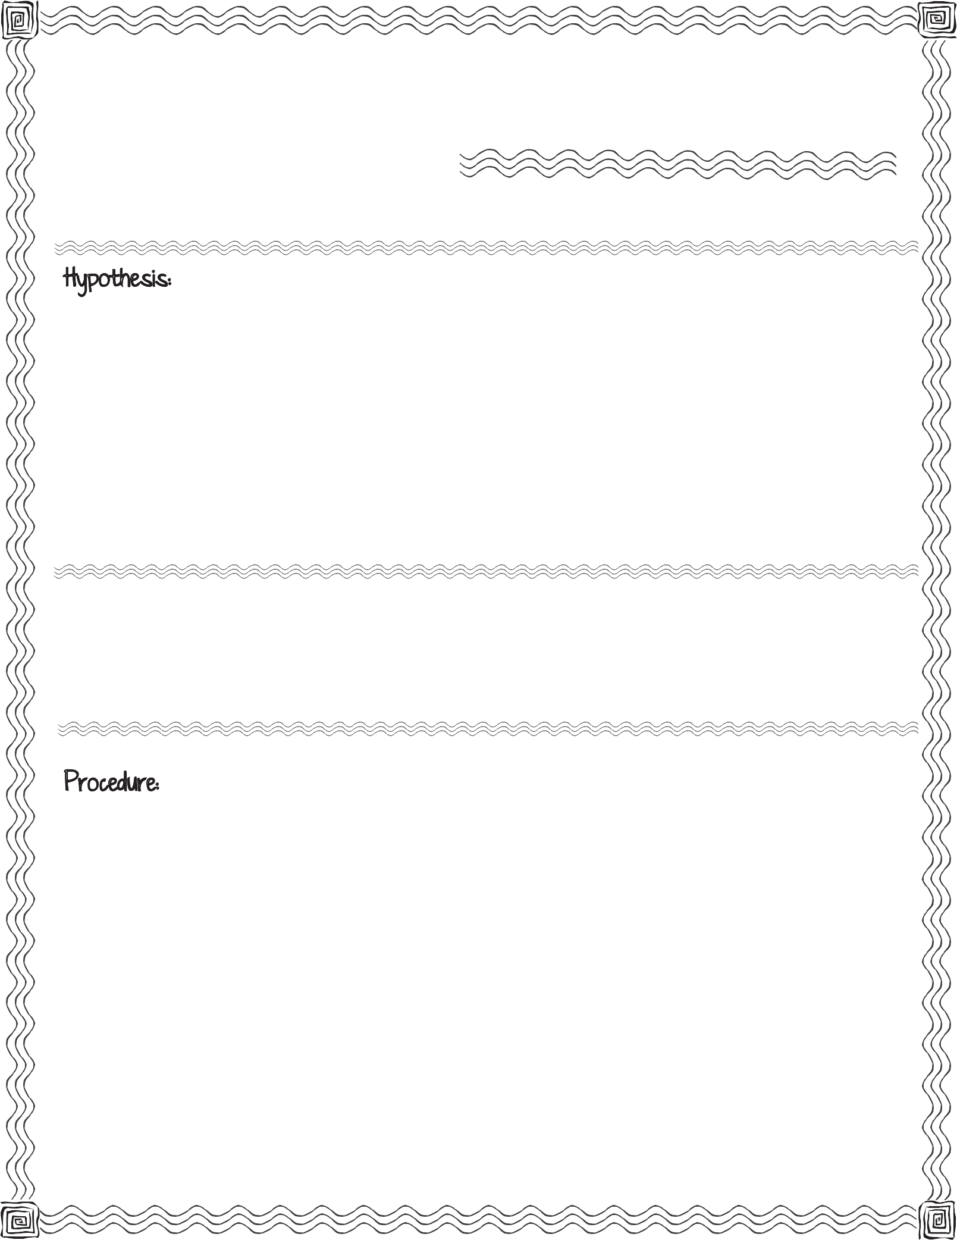

First, read the procedure below. Then write your hypothesis for what you think will happen when the balloon is lifted up over the bottle and the baking soda is allowed to drop down into the vinegar.

small uninflated balloon, small funnel, empty plastic water bottle, baking soda, vinegar, measuring cup (1/2 cup), measuring spoon (tablespoon)

Using the funnel, put 2 tablespoons of baking soda into the uninflated balloon. Pour 1/2 cup vinegar into the empty plastic water bottle.
Carefully fit the balloon over the bottle opening (be careful not to drop the baking soda into the vinegar).

Once the balloon is fitted snugly on the nozzle, hold up the balloon and allow the baking soda to fall into the vinegar.

Observe.

Record observations.

Record what you observe when you allow the baking soda to fall down into the vinegar.

Picture Time:

Before
After

Compare your hypothesis to the real outcome:

Up, Up & Away

A Chemical Reaction Investigation

