Spinning Penny
Name:

A Forces Investigation

First, read the procedure below. Next, write your hypothesis for what you think will happen when you swirl an inflated balloon with a penny inside.

clear balloon, penny

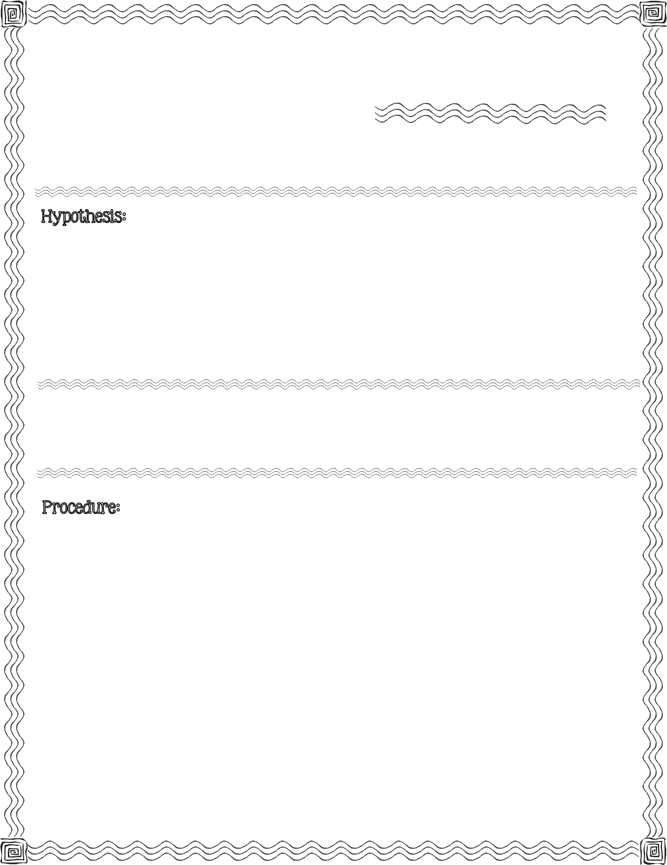

- Squeeze the penny through the mouth of an uninflated balloon. Allow penny to drop inside balloon and fall to the opposite end from the balloon opening.

- Inflate the balloon by blowing air into it.

- Tie the end of the balloon.

- Observe. Record observation (on back).
2013 Mrs. B’s Best

- Hold the tied end, palm down (like you would a bowling ball).

- Swirl balloon in a circular motion. You may use other hand on the other end of the balloon to gently help stabilize your circular movement.

- Swirl for 15 seconds then stop.

- Observe. Record observation (on back).
c

Record what you observe right after you have tied the balloon.

Record what you observe after swirling the balloon in a circular motion for 15 seconds.

Conclusion & Results:

Compare your hypothesis to the real outcome:

Spinning Penny

A Forces Investigation

t

