Spaghetti Dance
Name:

A Density Investigation

First, read the procedure below. Next, write your hypothesis for what you think will happen to a glass filled with water, vinegar and spaghetti after you add baking soda.

large clear container (quart size or greater), cooked spaghetti, water, vinegar, baking soda, food coloring, measuring cups

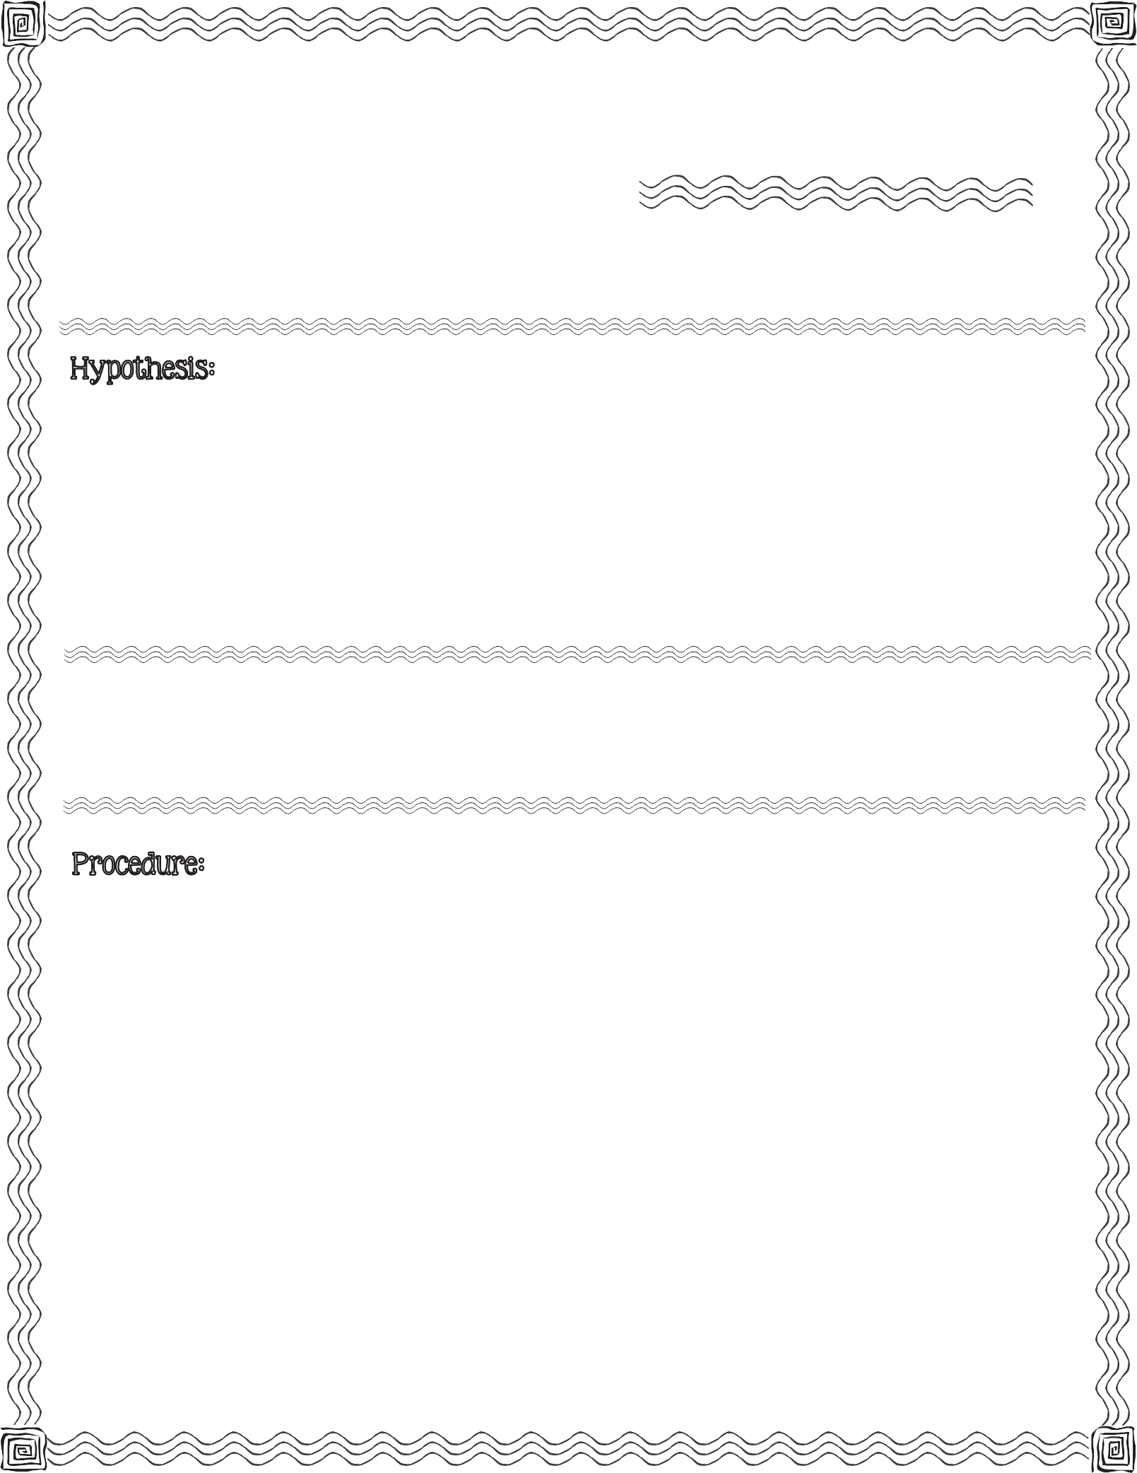

  - Pour 2 cups of water into the clear container.

  - Add 2 cups of vinegar to the water in the clear container.

  - Add 5 drops of food coloring to the vinegar and water mixture.

  - Add 10 strands of cooked spaghetti to the clear container.
2013 Mrs. B’s Best

  - Observe. Record observation (on back).

  - Drop 1 tablespoon of baking soda into the clear container.

  - Observe. Record observation (on back).
c

Record what you observe right after you place the spaghetti in the vinegar and water mixture.

Record what you observe after you drop 1 tablespoon of baking soda in the clear container.

Conclusion & Results:

Compare your hypothesis to the real outcome:

Spaghetti Dance

A Density Investigation

