Pass the Pepper
Name:

A Surface Tension Investigation

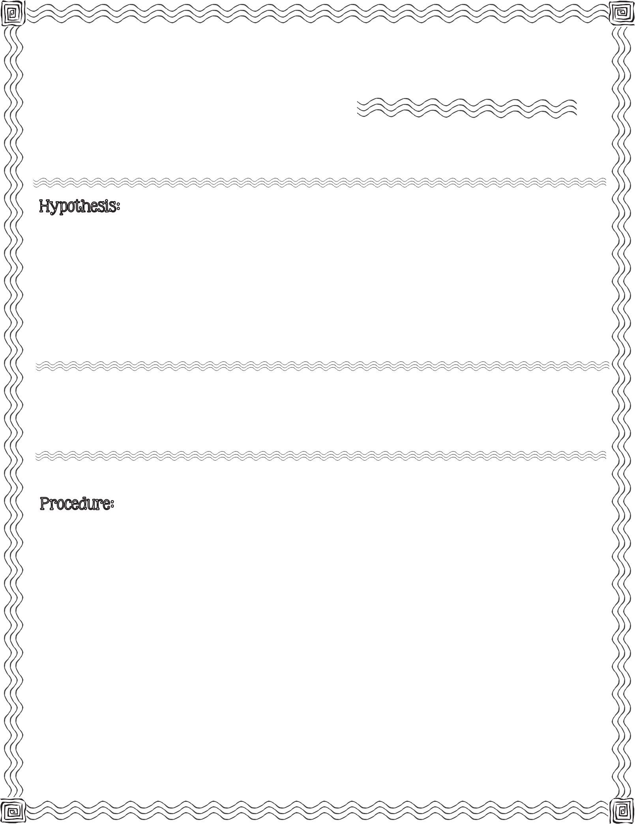
c

First, read the procedure below. Next, write your hypothesis for what you think will happen when you squeeze a drop of dish detergent into a bowl of water that has been sprinkled with pepper.

black pepper, small bowl, water, liquid dish detergent, measuring cup

- Fill the bowl with 1/2 cup of water.

- Sprinkle the water with black pepper. About 5 good shakes.

- Carefully squeeze one drop of liquid dish detergent into the middle of the bowl.

- Observe. Record observation (on back).
2013 Mrs. B’s Best

Illustrate what you observed before adding the dish detergent and after adding the dish detergent.

Before After

Describe the illustrations.

Conclusion & Results:

Compare your hypothesis to the real outcome:

Pass the PepperA Surface Tension Investigation

