Muscle Sand
Name:

A Forces Investigation

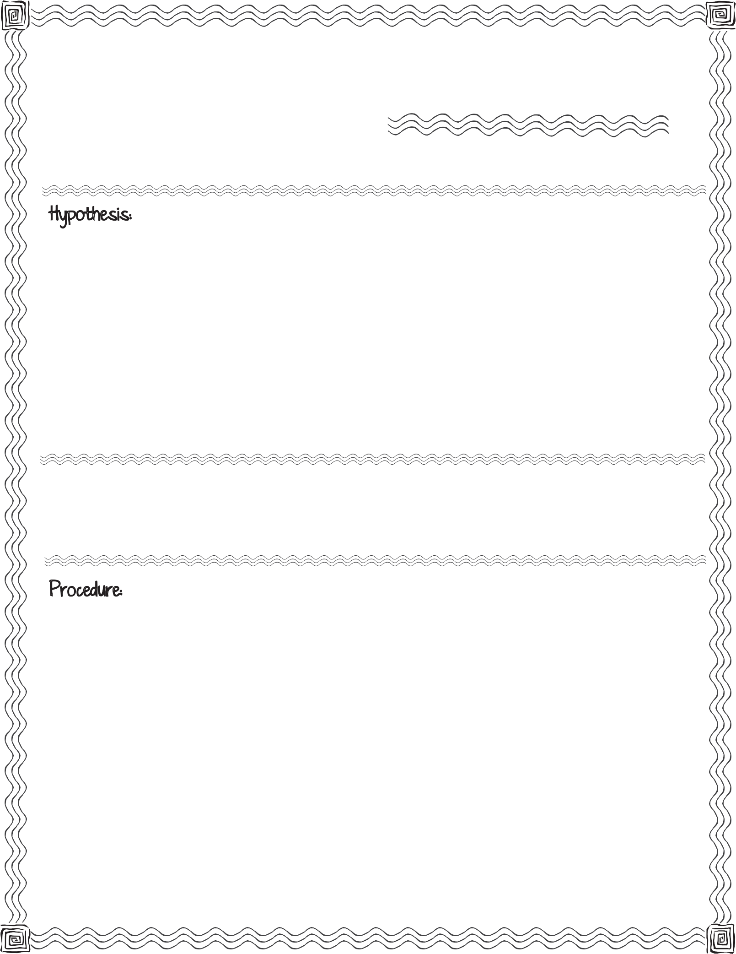

First, read the procedure below. Then write your hypothesis for what you think will happen when you try to poke a wooden rod through tissue paper covering a hollow paper towel roll. Write a second hypothesis for what you think will happen when you try to poke a wooden rod through tissue paper covering a paper towel roll filled with sand.

paper towel cardboard tube, sand, tissue paper, rubber band, wooden dowel (12 inches long)

Cut two 8 inch by 8 inch squares out of the tissue paper.

Cover the end of the cardboard tube with one of the squares of tissue paper. Tightly secure the tissue paper with the rubber band.
While one person holds the tube, have a second person put the stick through the tube and poke a hole in the tissue paper.

Replace the tissue paper with the second square of tissue paper. Secure with rubber band.

Fill the cardboard tube with sand.

While one person holds the tube, have a second person push the stick into the sand and poke a hole in the tissue paper. Record results.

Record what you observe when you poke the tissue paper covering the empty cardboard tube.

Record what you observe when you poke the tissue paper covering the cardboard tube filled with sand.

Compare your hypothesis to the real outcome:

Muscle Sand

A Forces Investigation

