Name:

It’s A Scream

A Sound Investigation

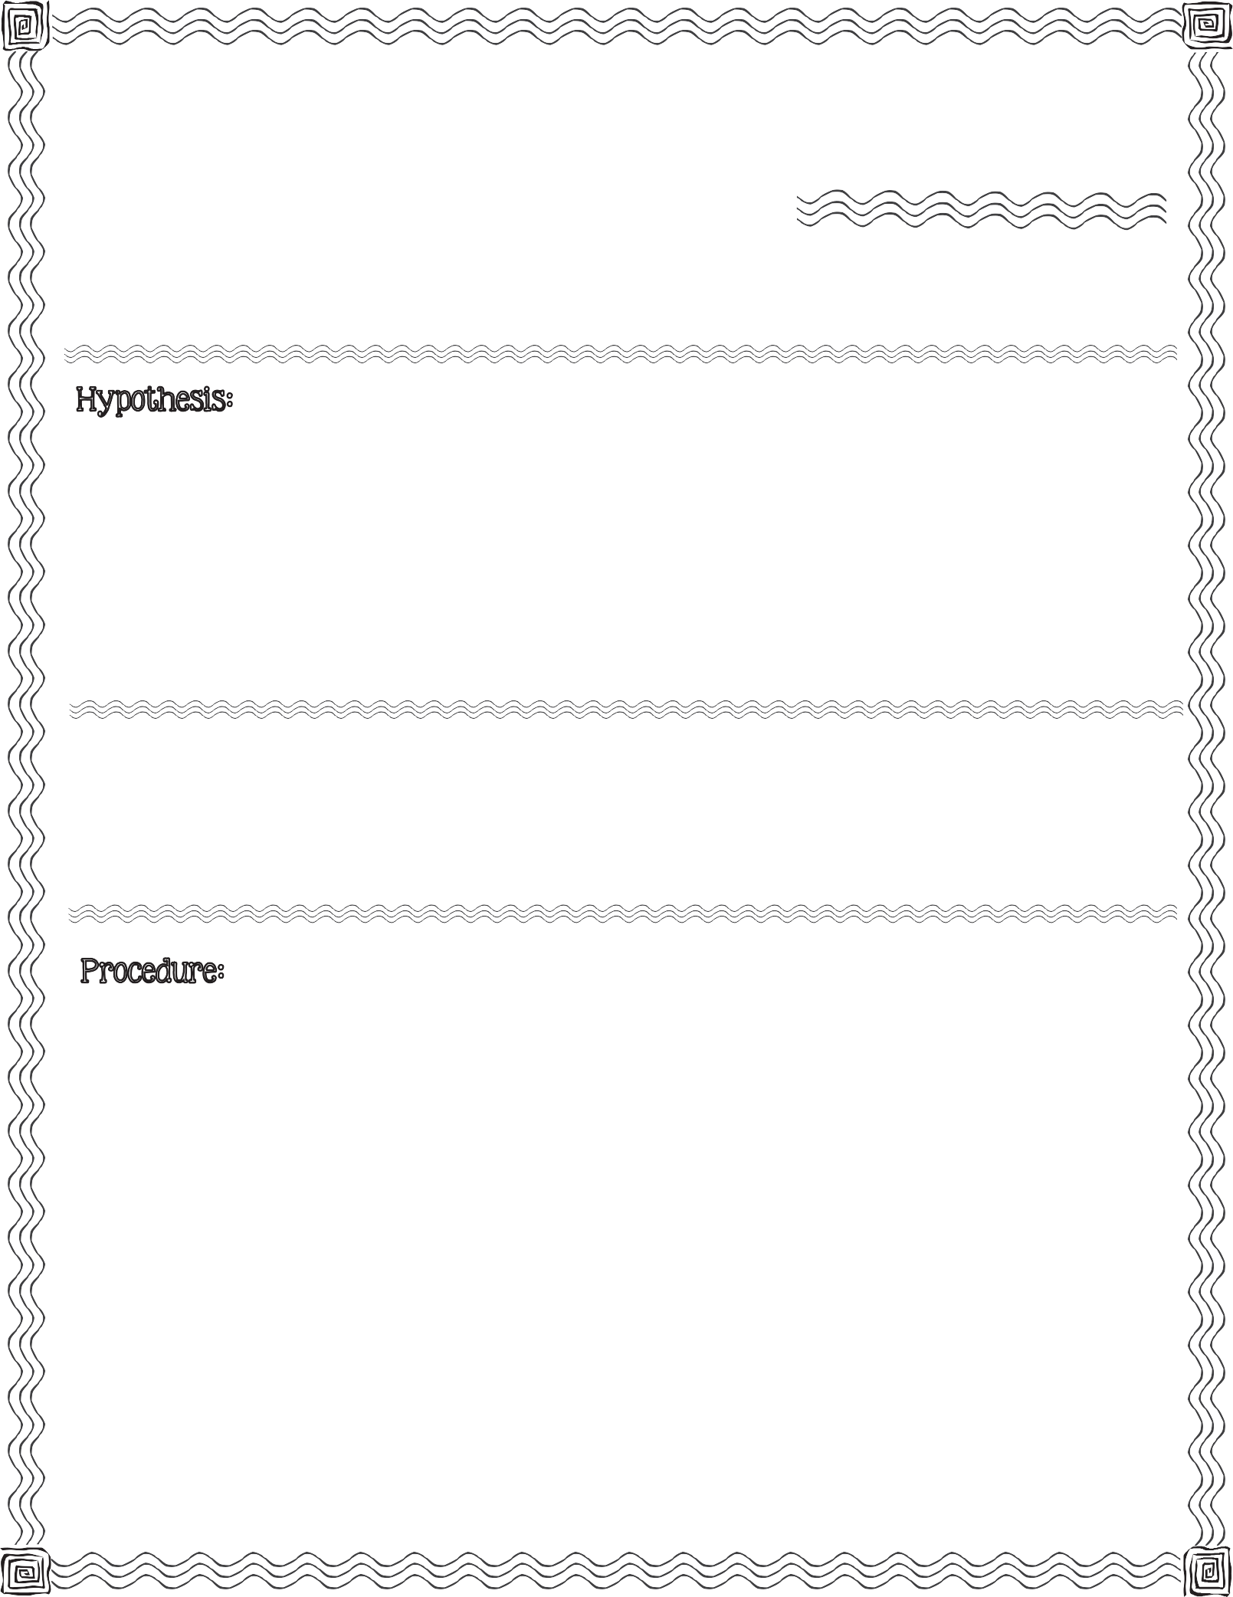

First, read the procedure below. Next, write your hypothesis for what you think will happen when you slide your fingers down a string tied to a plastic cup.

large disposable plastic cup, scissor, yardstick, string, water, violin rosin (optional)

  - Gently poke a small hole in the bottom of the cup. Your teacher may have already completed this step for you.

  - Using the yardstick, measure a 24-inch piece of string and cut with scissors.

  - Thread the string through the hole in the cup allowing the string to hang out the bottom of the cup. Tie a knot in the string to secure it to the cup.
2013 Mrs. B’s Best

  - Coat the string with water or violin rosin.

  - Hold the cup in one hand. With your other hand, pinch the string between your thumb and forefinger.

  - Squeeze tightly on the string as you slide your thumb and forefinger down the string.

7) Be patient...it may take several tries before you observe any results!
c

Record what happens the first time you slide your thumb and forefinger down the coated string.

Record how many attempts it takes before you observe any changes. Describe the changes your observe.

Conclusion & Results:

Compare your hypothesis to the real outcome:

It’s A Scream

A Sound Investigation

