Hot Reaction
Name:

A Chemical Reaction Investigation

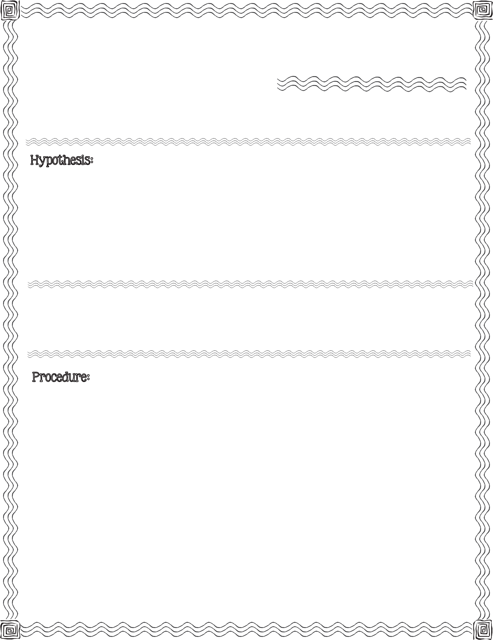

First, read the procedure below. Next, write your hypothesis for what you think will happen when steel wool soaked in vinegar is placed inside a sealed glass jar.

steel wool, vinegar, small bowl, tall glass jar with lid, thermometer

  - Your teacher will give you a piece of steel wool. Place the steel wool into the bowl.

  - Pour vinegar over the steel wool until it is completely covered. Soak for 3 minutes.

  - Carefully remove the steel wool from the bowl. Allow excess vinegar to drain off the steel wool.

  - Record the temperature displayed on the thermometer (Question #1 on back).
2013 Mrs. B’s Best

  - Gently wrap the steel wool around the bottom of the thermometer.

  - Place the steel wool wrapped thermometer in the glass jar. Place the lid on jar.

  - Monitor the thermometer’s temperature for about 5 minutes.
c

- Record the temperature displayed on thermometer before it is wrapped with steel wool and sealed in the glass jar.

- Record your observations and changes.

At start.
After 2 minutes.
After 5 minutes.

Changes: Changes: Changes:

Describe Results:

Compare your hypothesis to the real outcome:

Hot Reaction

A Chemical Reaction Investigation

