Disappearing Money
Name:

A Refraction Investigation

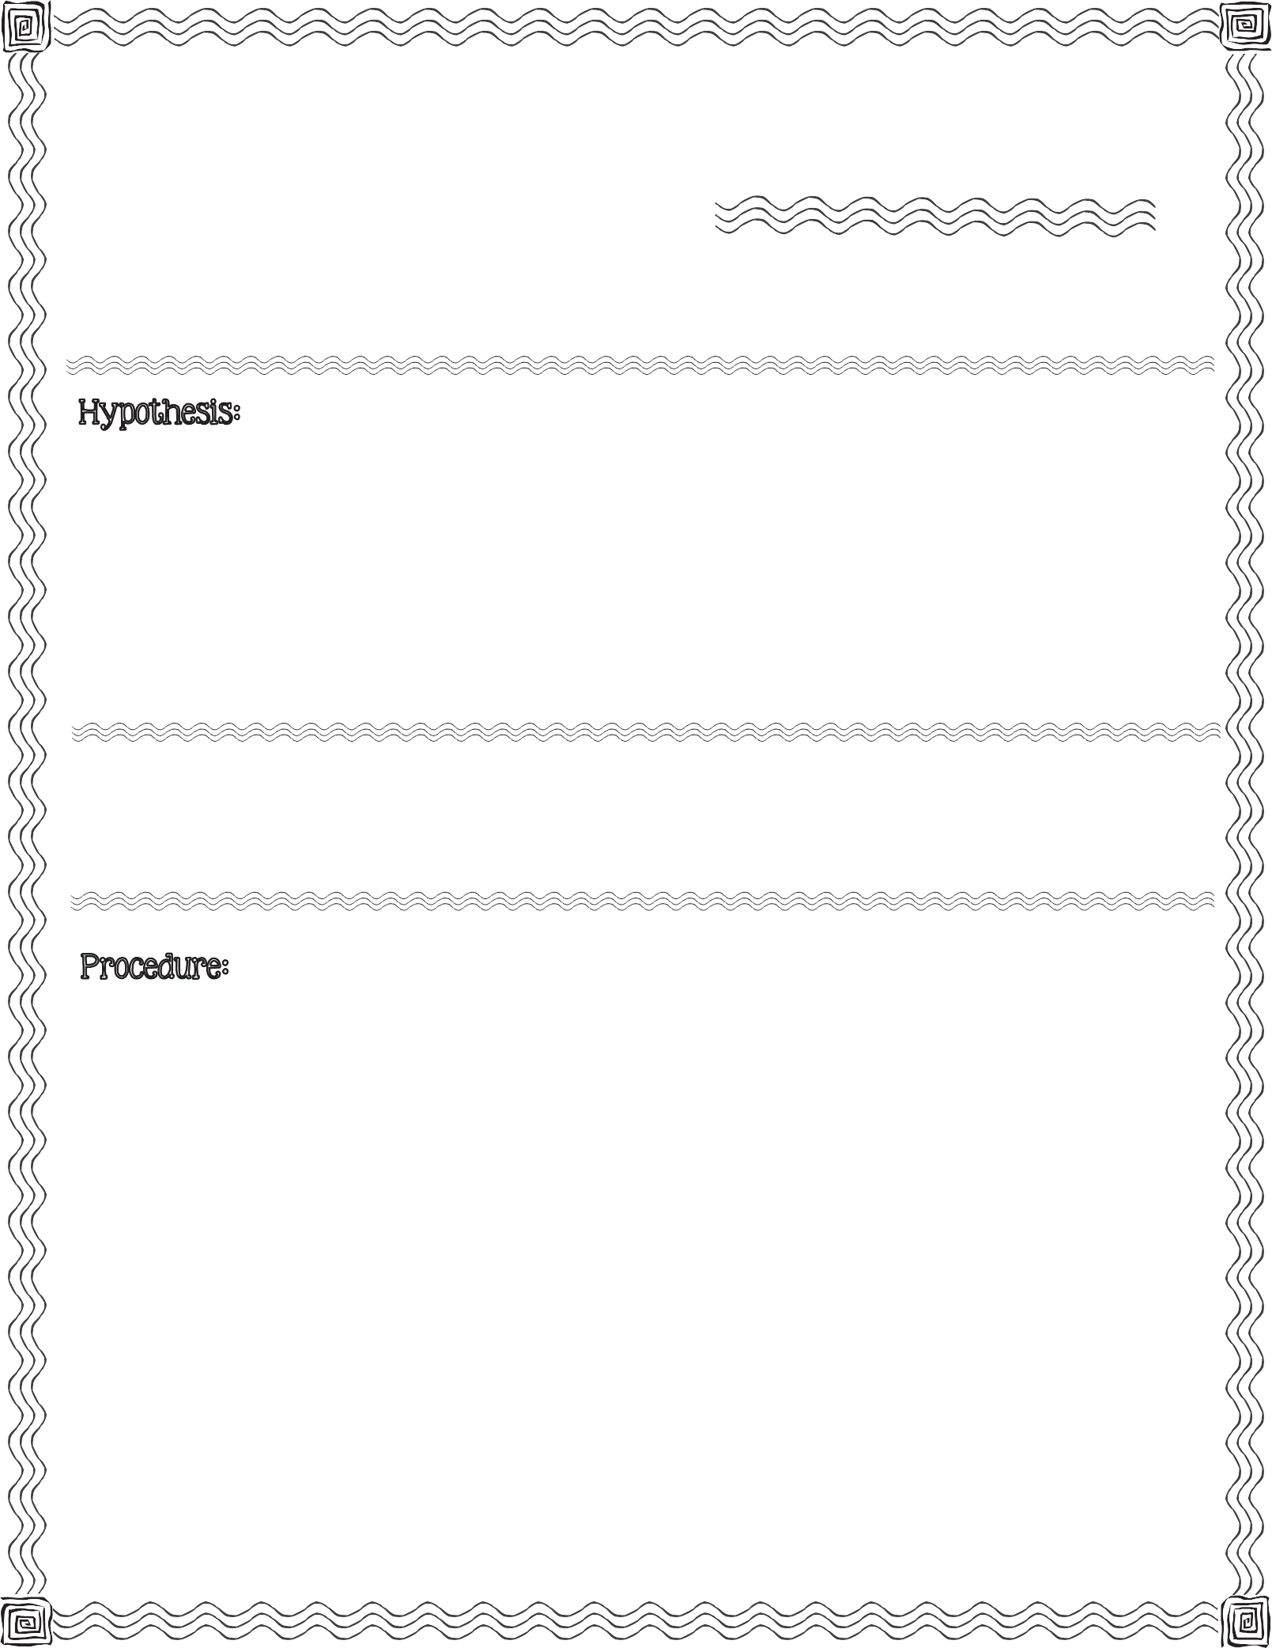

First, read the procedure below. Next, write your hypothesis for what you think will happen when you place a glass of water on top of a penny.

clear drinking glass, saucer, water, penny

- Set a penny on a flat surface like your desk.

- Set the drinking glass on top of the penny.

- Cover the top of the glass with the small saucer.

- Look through the side of the glass. Record what you observe on back. (Question #1)

- Remove the saucer and fill the glass with water. Replace the saucer.
2013 Mrs. B’s Best

- Look through the side of the glass. Record what you observe on back. (Question #2)

- Remove the saucer from the glass.

- Look straight to the bottom of the glass through the water. Record what you observe on back. (Question #3)
c

- Record your observation after completing Step 4 in the Procedure.

- Record your observation after completing Step 6 in the Procedure.

- Record your observation after completing Step 8 in the Procedure.

Describe Changes & Results:

Compare your hypothesis to the real outcome:

Disappearing Money

A Refraction Investigation

