Climbing Colours
Name:

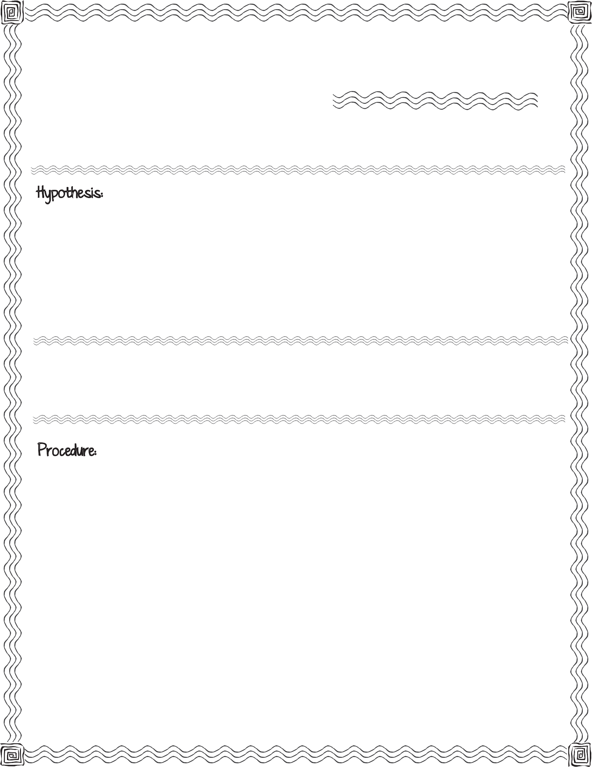
A Chromatography Investigation

First, read the procedure below. Then write your hypothesis for what you think will happen after you place the filter strip in the water:

washable coloured marker, coffee filter, small plastic cup, water, measuring cup, scissors, ruler

Fill the measuring cup with 50 milliliters of water. Pour the 50 milliliters of water into the plastic cup.
Using the ruler for measuring, cut a 1 inch wide by 5 inch long strip out of the coffee filter.

Lay the coffee filter strip on your desk so that it is 1 inch wide and 5 inches tall. Use your ruler to measure up 2 inches from the bottom of the strip.
With your marker draw a thick line across the strip, 2 inches from the bottom.

Carefully take your strip and set the end closest to the mark in the cup with 50 milliliters of water.

Observe.

Record what you observe right after the strip is placed in the water:

Record what you observe after 5 minutes:

Conclusion & Results:

Compare your hypothesis to the real outcome:

Climbing Colours

A Chromatography Investigation

