Change A Diaper
Name:

A Chemistry Investigation

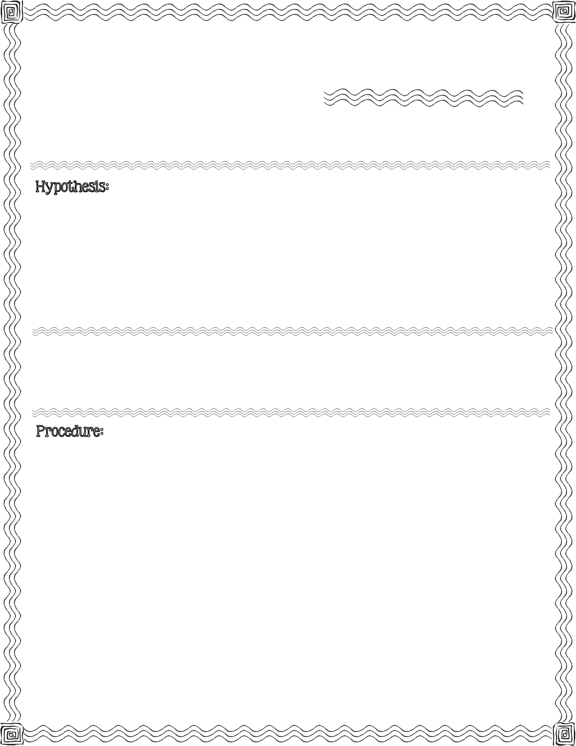

First, read the procedure below. Next, write your hypothesis for what you think will happen when you add water to crystals removed from a clean diaper.

disposable diaper, zip lock bag, scissors, 8 oz. plastic up, water, newspaper

- Place disposable diaper on the piece of newspaper.

- Carefully cut through the inside lining and remove all the cotton-like material. Place stuffing into the zip-lock bag.

- Scoop up any powdery crystals that may have spilled. Pour it into the zip-lock bag.

- Blow air into the bag to make it puff up like a pillow. Seal the bag.
2013 Mrs. B’s Best

- Shake bag for a few minutes to separate the powdery crystals from the stuffing.

- Carefully remove the stuffing from the bag leaving the powdery crystals behind.

- Pour the powdery crystals into plastic cup and fill the cup with water.

- Mix with your finger until mixture thickens.

- Observe.
c

Turn the cup upside down. Describe what happens.

Remove the mixture from the cup. Using your senses, describe the substance.

Conclusion & Results:

Compare your hypothesis to the real outcome:

While the mixture is not harmful, it is important that the mixture be thrown in the trash and all classroom investigators wash their hands.

Change A Diaper

A Chemistry Investigation

