Blown Away
Name:

A Forces and Motion Investigation

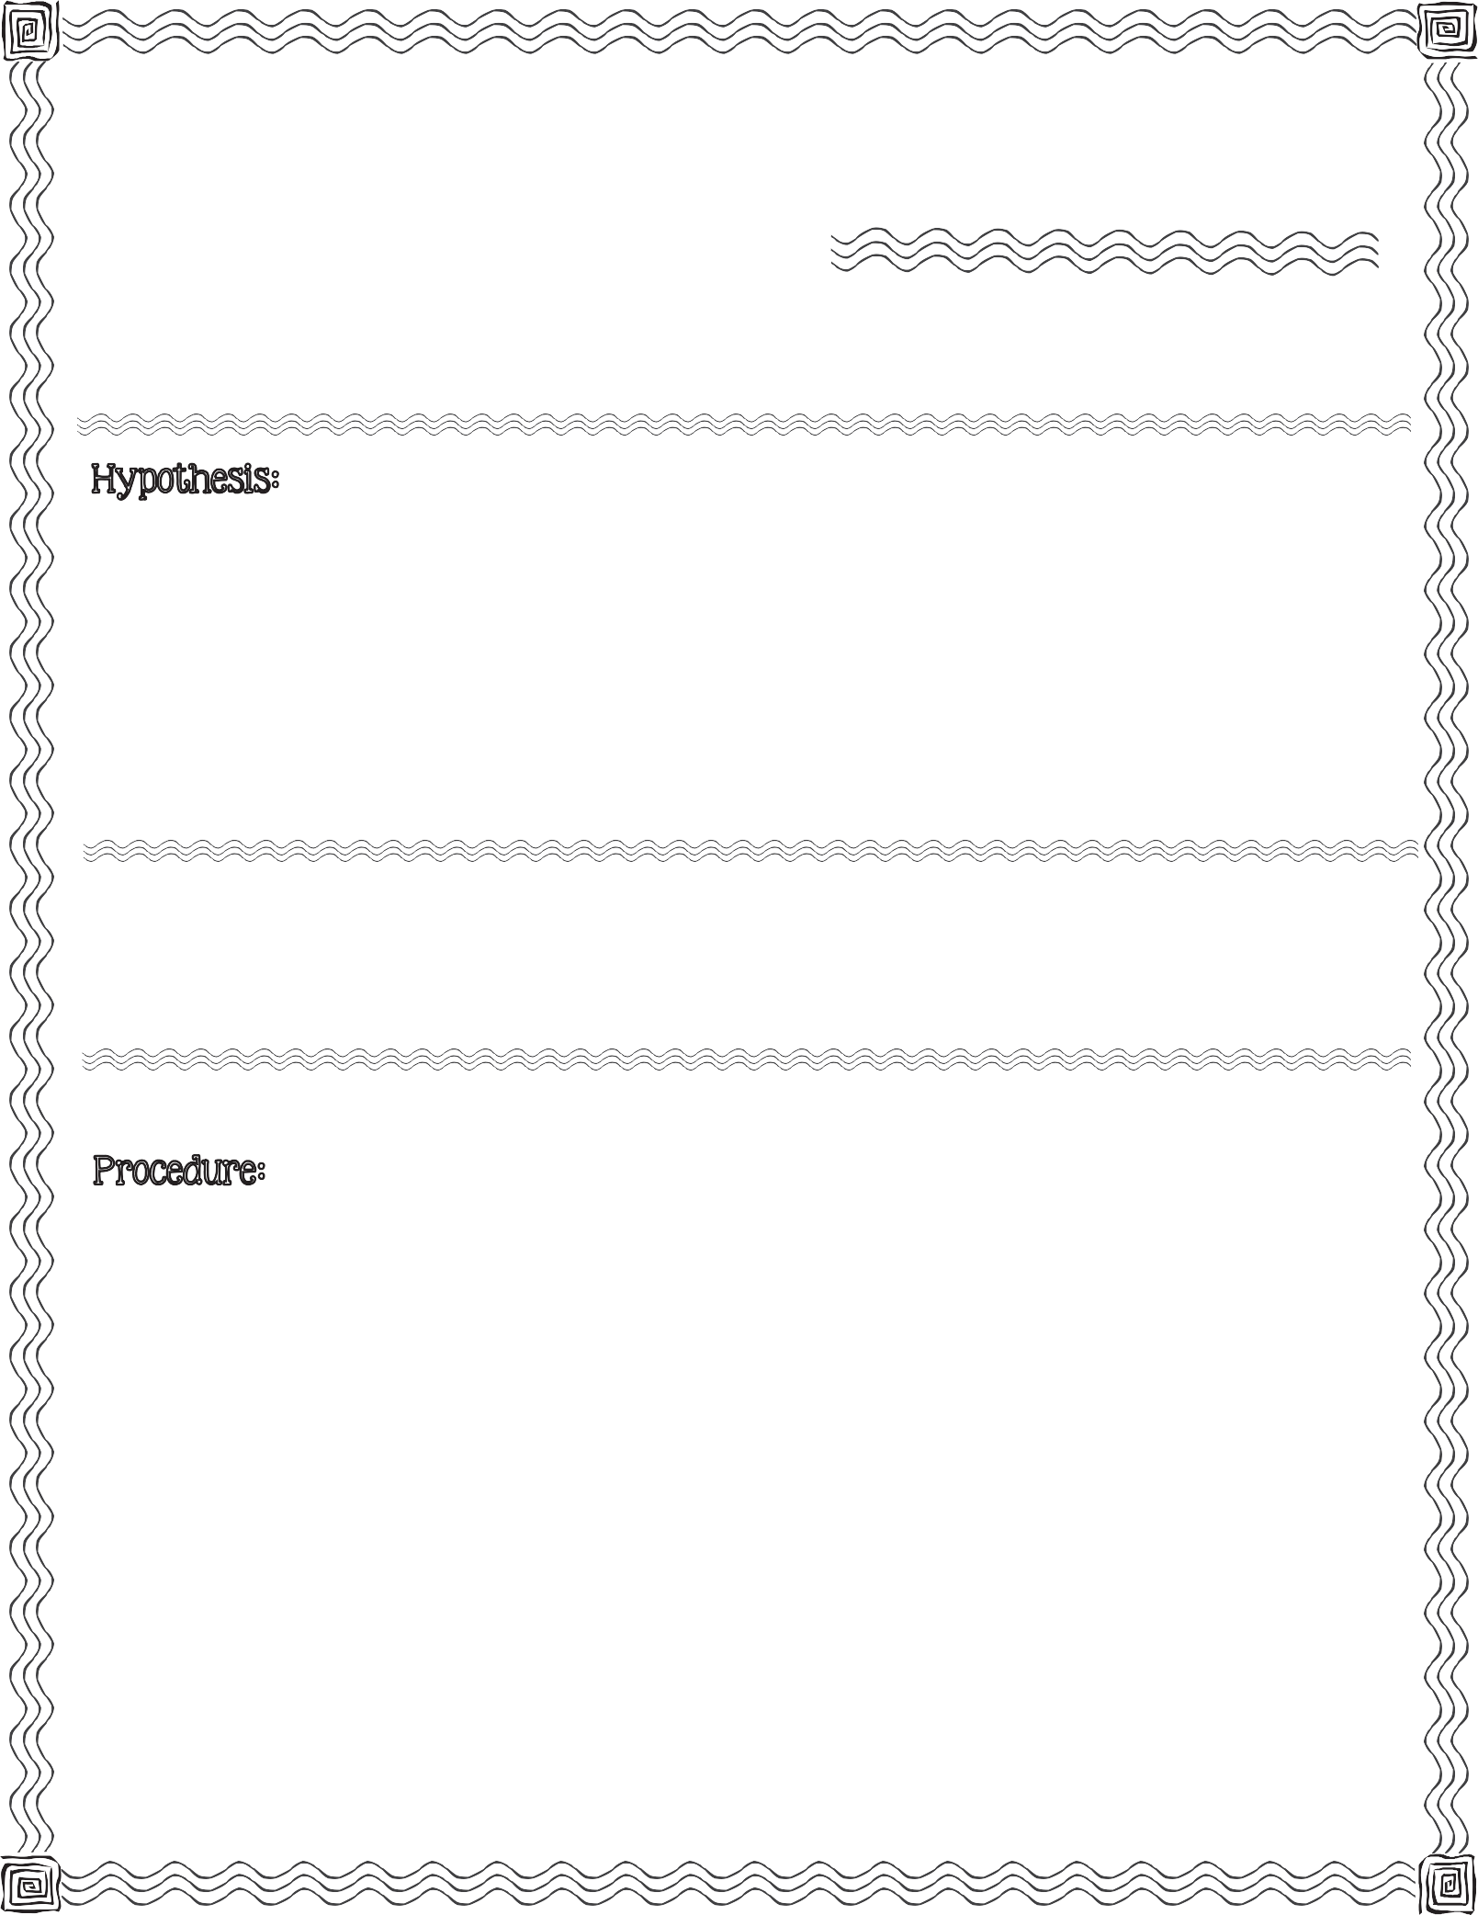

First, read the procedure below. Next, write your hypothesis for what you think will happen when you use a straw to blow a small paper ball into the opening of a soda bottle.

small paper ball, large plastic soda bottle, straw

- Make paper ball by wadding up a piece of paper. The ball must loosely fit inside the bottle opening.

- Lay the soda bottle on it’s side.

- Place the paper ball in the opening of the bottle.
2013 Mrs. B’s Best

- Aim the straw at the opening of the bottle and blow the paper ball into the bottle.

- Observe 1st attempt. Record observation (on back).

- Repeat procedure.

5) Observe 2nd attempt. Record observation (on back).
c

Record what happens after your FIRST attempt to blow the paper ball into the opening of the bottle.

Record what happens after your SECOND attempt to blow the paper ball into the opening of the bottle.

Conclusion & Results:

Compare your hypothesis to the real outcome:

Blown Away

A Forces and Motion Investigation

