A String of Ice
Name:

A Chemistry Investigation

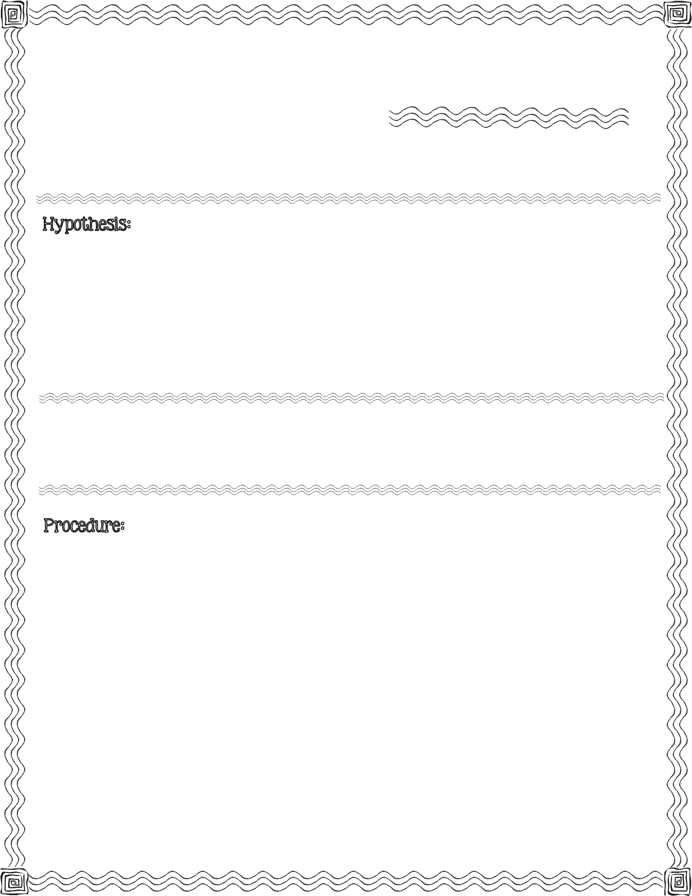

First, read the procedure below. Next, write your hypothesis for what you think will happen when you sprinkle salt around a string as it lies on an ice cube floating in water.

Kosher salt, string, ruler, glass, water, ruler, ice cube

- Fill the glass with water, stopping approximately an inch from the top.

- Measure 12 inches of string and cut.

- Place the ice cube into the glass of water.

- Lay the string across the top of the floating ice cube.

- Sprinkle some salt onto and around the string where it is touching the ice cube.
2013 Mrs. B’s Best

- Wait 15 seconds. While waiting, observe and record any changes (on back).

- Carefully lift the string.

- *Observe. Record observation (on back).

*If no changes are observed, repeat steps 5 - 8.
c

Record any changes you observe while waiting the 15 seconds after sprinking the salt on the ice cube.

Record what you observe when carefully lifting the string.

Conclusion & Results:

Compare your hypothesis to the real outcome:

A String of Ice

A Chemistry Investigation

