A Stalactite Show
Name:

A Chemistry Investigation

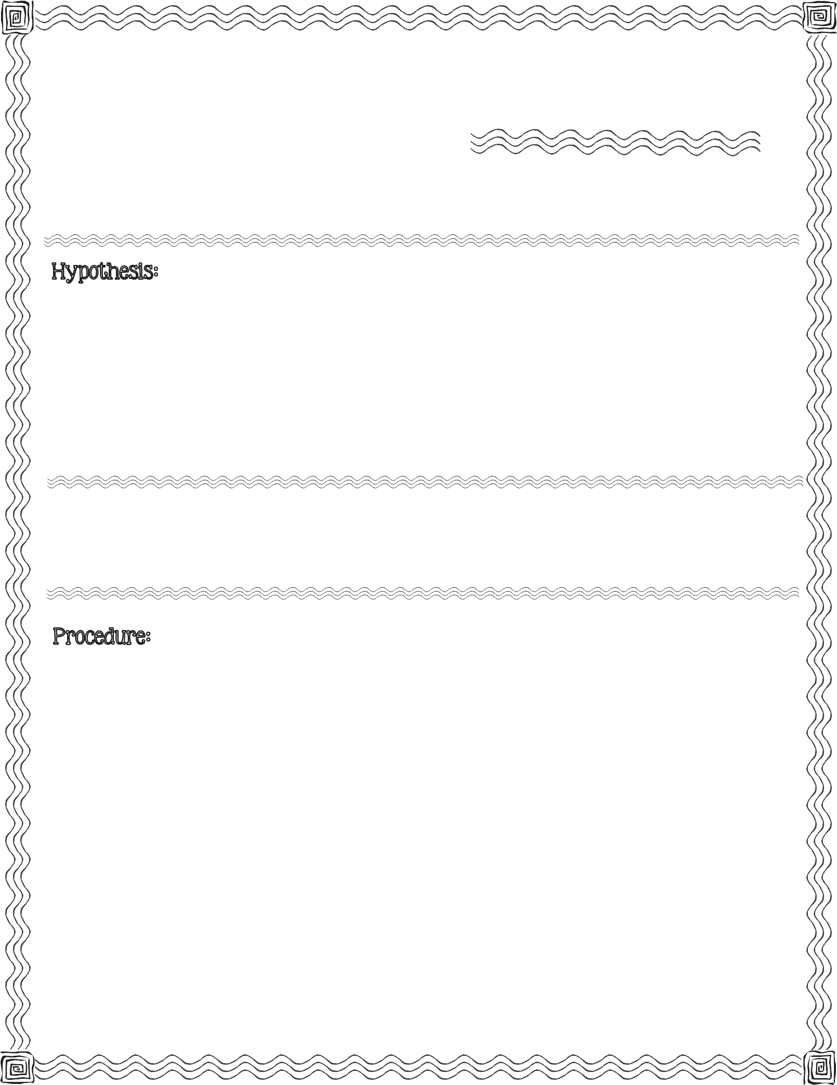

First, read the procedure below. Next, write your hypothesis for what you think will happen when you place two tips of a washcloth in a glass of water and washing soda.

washing soda, hot water, large washcloth, string, scissors, spoon, small plate, two glasses

- Fill the two glasses with hot water, leaving an inch at the top of each glass.

- Add 1/2 cup of washing soda to each glass. Stir until all washing soda is dissolved.

- Fold washcloth in half to form a triangle. Next, roll the washcloth so it looks like a stick.

- Cut three 6 inch lengths of string.

- Tie the string around the washcloth on both ends and in the middle. Trim the excess string off of the knots.
2013 Mrs. B’s Best

- Put each end of the washcloth into its own glass. The ends must touch the bottoms of the glass.

- Pull the center of the washcloth down so that it hangs towards the table. Put a plate under the center of the washcloth.

- Check back during the 10 day waiting period to see what happens.
c

Illustrate your observations:

Day 1
Day 4

Day 7
Day 10

Describe Changes & Results:

Compare your hypothesis to the real outcome:

A Stalactite Show

A Chemistry Investigation

