A Groovy Cube
Name:

A Density Investigation

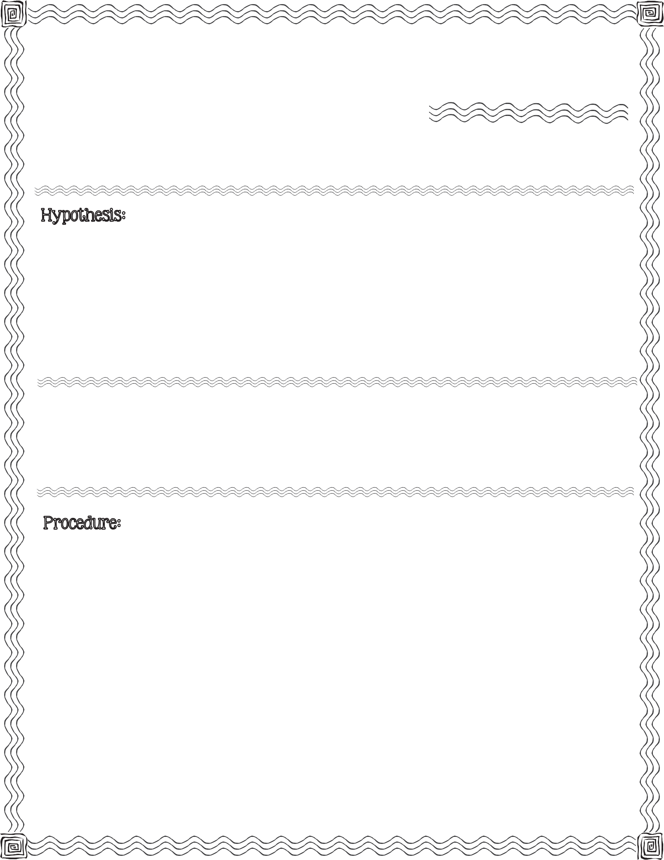

First, read the procedure below. Next, write your hypothesis for what you think will happen when you drop an ice cube in a glass filled with vegetable oil and baby oil.

clear drinking glass, food coloring, vegetable oil, baby oil, ice cube

- Add 2 drops of food coloring to the clear drinking glass.

- Fill the drinking glass halfway with vegetable oil.

- Fill the remainder of the drinking glass with baby oil. Stop an inch from the top.

- Observe. Record your observation (Question #1 on back).
2013 Mrs. B’s Best

- Gently drop an ice cube into the drinking glass. Record your observation (Question
#2 on back).

- Monitor the ice cube for 30 minutes. Record your observations every 10 minutes (Question #3 on back).
c

- Record what you observe after filling the drinking glass with vegetable oil and baby oil.

- Record what you observe after dropping the ice cube in the drinking glass.

- Record what you observe...

After 10 minutes.
After 20 minutes.
After 30 minutes.

Changes: Changes: Changes:

Compare your hypothesis to the real outcome:

A Groovy Cube

A Density Investigation

